[Skip to main content](https://link-springer-com.erl.lib.byu.edu/article/10.1007/s10055-018-0359-y" \l "main-content)[Skip to sections](https://link-springer-com.erl.lib.byu.edu/article/10.1007/s10055-018-0359-y#article-contents)

Advertisement

Hide

[SpringerLink](https://link-springer-com.erl.lib.byu.edu/" \o "Go to homepage)

[Search](https://link-springer-com.erl.lib.byu.edu/article/10.1007/s10055-018-0359-y#search-container)

* [Home](https://link-springer-com.erl.lib.byu.edu/)

* [Log in](https://link-springer-com.erl.lib.byu.edu/signup-login?previousUrl=https%3A%2F%2Flink.springer.com%2Farticle%2F10.1007%2Fs10055-018-0359-y)

[Virtual Reality[](https://link-springer-com.erl.lib.byu.edu/journal/10055)](https://link-springer-com.erl.lib.byu.edu/journal/10055)

[Virtual Reality](https://link-springer-com.erl.lib.byu.edu/journal/10055)

pp 1–6| [Cite as](https://link-springer-com.erl.lib.byu.edu/article/10.1007/s10055-018-0359-y#citeas)

A comparative study between a virtual reality heart anatomy system and traditional medical teaching modalities

* [Authors](https://link-springer-com.erl.lib.byu.edu/article/10.1007/s10055-018-0359-y#authors)
* [Authors and affiliations](https://link-springer-com.erl.lib.byu.edu/article/10.1007/s10055-018-0359-y#authorsandaffiliations)
* Salsabeel F. M. Alfalah
* Jannat F. M. Falah
* Tasneem Alfalah
* Mutasem Elfalah
* Nadia Muhaidat
* Orwa Falah

1. 1.
2. 2.
3. 3.
4. 4.
5. 5.
6. 6.

S.I. : Virtual Reality, Augmented Reality and Commerce

**First Online:**27 July 2018

* 74Downloads

Abstract

The aim of using virtual reality (VR) as a medical training tool is to offer additional means to teach students and to improve the quality of medical skills. A novel system was developed to fulfil the requirements of modern medical education and overcome the challenges faced by both students and lecturers in the process of knowledge transfer. A heart three-dimensional model presented in a virtual reality (VR) environment has been implemented in order to facilitate a new educational modality. This paper reports the outcome of a comparative study between traditional medical teaching modalities and virtual reality technology. This study was conducted in the Faculty of Medicine in the University of Jordan. The participants were asked to perform system trials and experiment with the system by navigating through the system interfaces, as well as being exposed to the traditional physical model of the human heart that is currently used in the faculty during practical anatomy sessions. Afterwards, they were asked to provide feedback via a comparative questionnaire. The participants’ replies to the questions regarding the Physical Heart Model and VR heart anatomy system were assessed for reliability using Cronbach’s alpha. The first group’s (Physical Heart Model questions) *α* value was 0.689. The second group’s (VR heart anatomy system questions) *α* value was 0.791. Comparing students’ experience results between the traditional method (Physical Heart Model) and the VR heart anatomy system, the mean scores showed a distinct increase in the values. This indicates that the developed system enhanced their experience in anatomy learning and the provided tools improved their understanding of heart anatomy. Results demonstrated the usefulness of the system by showing a higher satisfaction rate for the provided tools regarding structure and visualisation.

Keywords

Medical education Virtual reality Anatomy Heart Comparative study

Access to this content is enabled by **BYU Library**

1 Introduction

The field of medical education is an ever-evolving area constantly enriched by newly discovered information and changing facts provided by active research in all areas of medicine. The educational system is facing a major challenge to contain this high volume of dynamic material and deliver it to future doctors in an efficient fashion.

Medical education requires practitioners to develop basic clinical skills before dealing with real patients (Engum et al. [2003](https://link-springer-com.erl.lib.byu.edu/article/10.1007/s10055-018-0359-y#CR6); Falah et al. [2014](https://link-springer-com.erl.lib.byu.edu/article/10.1007/s10055-018-0359-y#CR9)). This is achieved by practicing on artificial models or non-viable tissue prior to training by interacting with the patient, to minimise to a great degree the incidence of human error, and relieve the trainee’s anxieties of dealing with real patients by acquiring a good level of skill prior to that stage. Furthermore, there are many applications that have been designed for various fields within medicine (Alfalah et al. [2013a](https://link-springer-com.erl.lib.byu.edu/article/10.1007/s10055-018-0359-y#CR1), [b](https://link-springer-com.erl.lib.byu.edu/article/10.1007/s10055-018-0359-y#CR2); Vozenilek et al. [2004](https://link-springer-com.erl.lib.byu.edu/article/10.1007/s10055-018-0359-y#CR17); Onyesolu [2009](https://link-springer-com.erl.lib.byu.edu/article/10.1007/s10055-018-0359-y#CR12); Sakellariou et al. [2011](https://link-springer-com.erl.lib.byu.edu/article/10.1007/s10055-018-0359-y#CR15); Gallo et al. [2010](https://link-springer-com.erl.lib.byu.edu/article/10.1007/s10055-018-0359-y#CR11); Falah et al. [2014](https://link-springer-com.erl.lib.byu.edu/article/10.1007/s10055-018-0359-y#CR9), [2015](https://link-springer-com.erl.lib.byu.edu/article/10.1007/s10055-018-0359-y#CR10)).

Despite the contemporary nature of medical knowledge, a large proportion of methods used in delivering this knowledge to students remain traditional. It is therefore becoming increasingly difficult to incorporate the complexity and diversity of medicine in a traditional teaching system (Falah et al. [2014](https://link-springer-com.erl.lib.byu.edu/article/10.1007/s10055-018-0359-y#CR9), [2015](https://link-springer-com.erl.lib.byu.edu/article/10.1007/s10055-018-0359-y#CR10)). There is also a pressing demand from newer generations of medical students to modernise current teaching methods in line with the developments and new technologies emerging in all areas of education.

One of the major subjects taught in the early years of medical undergraduate studies is anatomy. This is one of the fundamental areas of medicine, and a sound anatomical knowledge impacts on all branches of the student’s future studies and career. The field of anatomy has evolved over centuries, and teaching methods used are still reflecting the traditional nature of this subject, often causing considerable struggle to students who are trying to keep up with the dynamic pace of the educational process (Falah et al. [2015](https://link-springer-com.erl.lib.byu.edu/article/10.1007/s10055-018-0359-y#CR10)). Recently, however, the demand is rising to introduce modern technologies to enhance this area.

The recent years have witnessed the introduction of a number of promising technologies and applications to medical education to meet this demand. There is already good evidence that this is of proven efficiency in improving the quality of the medical educational process (Sakellariou et al. [2009](https://link-springer-com.erl.lib.byu.edu/article/10.1007/s10055-018-0359-y#CR14); Peterson and Robertson [2013](https://link-springer-com.erl.lib.byu.edu/article/10.1007/s10055-018-0359-y#CR13)).

Virtual reality (VR) applications are considered one of the evolving methods that have contributed to enhancing medical education (Charissis and Papanastasiou [2010](https://link-springer-com.erl.lib.byu.edu/article/10.1007/s10055-018-0359-y#CR3); Falah et al. [2012](https://link-springer-com.erl.lib.byu.edu/article/10.1007/s10055-018-0359-y#CR7), [2013](https://link-springer-com.erl.lib.byu.edu/article/10.1007/s10055-018-0359-y#CR8), [2014](https://link-springer-com.erl.lib.byu.edu/article/10.1007/s10055-018-0359-y#CR9)). This research utilises virtual reality to provide an enhancement to the traditional methods of delivering anatomical knowledge to medical students via tool that augments the teaching process from both a students’ and lecturers’ point of view and to prove the positive impact of such technology in this particular field.

2 Experiment rationale

The developed system offers a real-time 3D representation of the heart structure in an interactive VR environment. The characteristics of the 3D heart model were designed to facilitate optimal delivery of knowledge to the user (Fig. [1](https://link-springer-com.erl.lib.byu.edu/article/10.1007/s10055-018-0359-y#Fig1)). Close resemblance to real-life colours and structure was considered to provide a better representation of the appearance of the live human heart. The ability to interact with the model and manipulate the many layers and anatomical parts enables the user to virtually dissect and explore the heart model to gain hands on exposure to its structure. Extensive labelling of the different parts of the heart and the opportunity to access a brief description of each structure allows the user to obtain theoretical knowledge while navigating through the system and associate this knowledge with the practical experience of dissecting the heart. The ability to edit the provided information by the lecturer allows for flexibility and dynamicity of the teaching and learning process. Furthermore, the developed VR heart anatomy system was evaluated by medical students, who already study the structure of the heart using traditional teaching modalities and are therefore able to appreciate any improvement or advancement this novel model may provide.

[Open image in new window[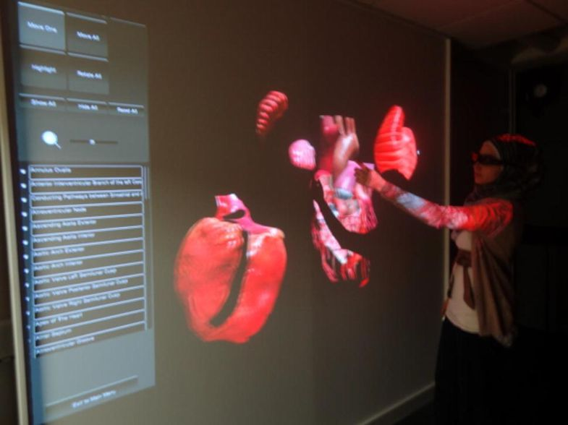](https://media.springernature.com/original/springer-static/image/art%3A10.1007%2Fs10055-018-0359-y/MediaObjects/10055_2018_359_Fig1_HTML.jpg)](https://media.springernature.com/original/springer-static/image/art%3A10.1007%2Fs10055-018-0359-y/MediaObjects/10055_2018_359_Fig1_HTML.jpg)

**Fig. 1**

Remote manipulation of 3D data in semi-immersive environment (projection wall). This figure shows the user using the system in the Virtual Reality laboratory using the projection wall and wearing active stereo 3D glasses (Glasgow Caledonian University/UK)

The focus of this paper was on the education field, specifically medical education. The main reason for choosing the medical field for this research arose from the need for extreme accuracy in its teaching methods. The process of educating and preparing a student to become a doctor requires methods ensuring that human error is minimised, as patient safety is the highest priority. See one, do one, and teach one, is not an acceptable way of learning in the modern educational systems, as the learning outcome has to be measurable, and the results have to be guaranteed.

The medical education environment that was chosen as a case study for this research was the Faculty of Medicine in the University of Jordan. However, the developed VR medical system is generic and the subject of the system (anatomy of the human heart) is a main part of the medical curriculum in any medical school; therefore, its usefulness would not be limited to a particular medical school and could be utilised as part of the anatomy curriculum due to the following features:

* Human–computer interaction (HCI) was taken into consideration whilst designing the system screens and providing adequate tools and functionalities.
* The provided medical information included common terms used in the medical field, as there is a variation in the medical terms among different textbooks, making it suitable for global knowledge.
* The system is accessible via different virtual environments, i.e. semi-immersive (3D laptop), fully immersive (CAVE), non-immersive (normal computer screen).

2.1 Participants

The system testing trials were conducted in the Faculty of Medicine in UJ. Sixty medical students completing their third year and beginning their fundamental skills training were recruited to participate in the trial.

2.2 Procedure

The students were aware that the trial time would include exposure to the developed system and be followed by a questionnaire. The questionnaire was distributed to the students and an explanation of the questionnaire’s purpose and how to complete the questionnaire was provided. Furthermore, the researcher was available during the trial and the questionnaire completion to answer any queries.

The participants were asked to experiment with the system by navigating through the system interfaces and using all the tools provided. The participants had the opportunity to:

* Manipulate the 3D heart model and identify each structure of the heart.
* Dissect the 3D heart model into layers to clarify anatomical relations of the different parts.
* Explore information about each component of the model.
* Explore the provided functionalities in the system.

Each trial started by clarifying to the participant the trial process and desired aim and time was provided to the participant to go through the trial description. Afterwards, the participant was asked to evaluate the system by navigating through the system’s interfaces and offered tools. Finally, the participant was asked to complete the questionnaire.

Trials were conducted for system evaluation individually. Furthermore, individuals were asked to navigate and view the heart model from different angles to determine the efficiency and effectiveness of the system use and recommend enhancements. Observations were made on how participants were performing, and their responses and their feedback about the system were recorded. Figure [2](https://link-springer-com.erl.lib.byu.edu/article/10.1007/s10055-018-0359-y#Fig2) depicts participants using the VR heart anatomy system.

[Open image in new window[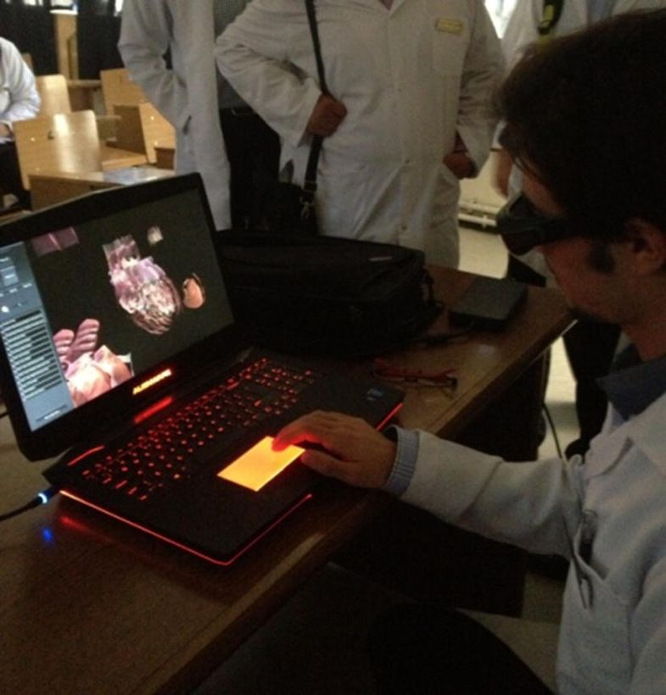](https://media.springernature.com/original/springer-static/image/art%3A10.1007%2Fs10055-018-0359-y/MediaObjects/10055_2018_359_Fig2_HTML.jpg)](https://media.springernature.com/original/springer-static/image/art%3A10.1007%2Fs10055-018-0359-y/MediaObjects/10055_2018_359_Fig2_HTML.jpg)

**Fig. 2**

Participant wearing the active stereo 3D glasses and navigating through the anatomy interface in the VR Anatomy System during the system trials (Faculty of Medicine in UJ)

The output data were analysed qualitatively and quantitatively. The researcher’s observation of the participant during the trial and the informal discussion after the trial were analysed qualitatively. These highlighted aspects of the system’s usability regarding enjoyment of the VR experience, efficiency of the modelling, and participants’ reactions to the system.

2.3 Questionnaire development

The research involved designing a comparative questionnaire. The questionnaire started with a covering letter that explains the purpose of the survey (Saunders et al. [2012](https://link-springer-com.erl.lib.byu.edu/article/10.1007/s10055-018-0359-y#CR16)).

The questionnaire contains 23 statements split into 2 groups that reflected anatomy-related issues. In the first group of questions, the students were asked to rate their experience in using the physical model method on a 5-point Likert scale (ranging from strongly disagree = 1, disagree = 2, moderate = 3, agree = 4 and strongly agree = 5). On the reverse side of the questionnaire (the second group of questions), students were then asked to rate their experience in using the VR Anatomy System (Fig. [2](https://link-springer-com.erl.lib.byu.edu/article/10.1007/s10055-018-0359-y#Fig2)). Overall students answered a total of 46 questions (23 rating physical model experiences against 23 rating VR Anatomy System experience). The questions measure the participants’ satisfaction about physical model and their behaviours in interpreting anatomy using VR Anatomy System.

In summary, the purpose of this questionnaire was to compare one of the traditional methods used for human anatomy learning (Physical Heart Model) with the developed VR Anatomy System.

3 Results and analysis

Each group of the questions (physical model and VR Anatomy System) was assessed for reliability using Cronbach’s alpha (Saunders et al. [2012](https://link-springer-com.erl.lib.byu.edu/article/10.1007/s10055-018-0359-y#CR16); Cronbach [1951](https://link-springer-com.erl.lib.byu.edu/article/10.1007/s10055-018-0359-y#CR4); Cronbach and Furby [1970](https://link-springer-com.erl.lib.byu.edu/article/10.1007/s10055-018-0359-y#CR5)). The first group (physical model questions) *α* (Cronbach’s alpha) value was 0.689. The second group (VR Anatomy System questions) *α* (Cronbach’s alpha) value was 0.791, as shown in Table [1](https://link-springer-com.erl.lib.byu.edu/article/10.1007/s10055-018-0359-y#Tab1).

**Table 1**

Cronbach’s alpha value for the two groups of questions in the comparative questionnaire that was used to compare between the physical model and the developed VR Anatomy System. The Cronbach’s alpha value showed excellent internal consistency for both of the questions groups

| **Comparison criteria** | **Cronbach’s alpha** |
| --- | --- |
| Physical model | 0.689 |
| VR Anatomy System | 0.791 |

The mean scores were measured for each question and for all questions in each criterion (physical model and VR Anatomy System) as shown in Table [2](https://link-springer-com.erl.lib.byu.edu/article/10.1007/s10055-018-0359-y#Tab2).

**Table 2**

Questionnaire results comparing mean value for physical model with VR Anatomy System, note that the bold values are the minimum and maximum mean values

|  | **Statements** | **Mean scores physical model** | **Mean scores VR Anatomy System** |
| --- | --- | --- | --- |
| 1. | Helps me to better understand and memorise the heart structure | 2.93 | 4.47 |
| 2. | Enhances the visualisation of the heart details | 3.12 | 4.57 |
| 3. | Will show clearly the relative position among the structures | 3.23 | 4.55 |
| 4. | Understanding heart structure is easier | 3.23 | 4.35 |
| 5. | Having an opportunity for repeating a training task | 2.62 | 4.75 |
| 6. | Is available when required | 2.05 | 4.63 |
| 7. | I think it is a good learning tool | 3.45 | 4.55 |
| 8. | Flexible enough for training | 2.83 | 4.57 |
| 9. | I can easily recognise the heart structure from different perspectives | 3.12 | 4.60 |
| 10. | Understanding heart anatomy structure is fast | 3.20 | 4.40 |
| 11. | I can easily navigate through the parts of the heart | 2.80 | 4.65 |
| 12. | Will save the time required to learn the basic anatomy | 3.28 | 4.20 |
| 13. | Will help me to develop basic anatomy skills prior to actual patient encounters | 3.47 | 4.00 |
| 14. | Will cover most of the heart anatomy | 3.27 | 4.42 |
| 15. | I think it can strengthen my intentions to learn | 3.32 | 4.43 |
| 16. | Reduce use of cadavers as learning method | 3.10 | 4.58 |
| 17. | Interaction is clear and simple while using it | 3.07 | 4.40 |
| 18. | I feel enjoyment while using it | 3.18 | 4.58 |
| 19. | It is easy to interact with others by using this system | 3.10 | 4.13 |
| 20. | I can dissect into layers to clarify anatomical relations of the different parts | 2.30 | 4.58 |
| 21. | It has pointers to provide information to the student about the components of the model | **1.33** | 4.73 |
| 22. | I can approach the heart structure from different angles | 2.93 | **4.77** |
| 23. | I can open in different planes to visualise cuts through the structures of the heart in several locations | 2.50 | **4.77** |
| 24. | The whole questions for each group (physical model against VR Anatomy System) | 2.91 | 4.51 |

The results were encouraging as it showed high mean scores for the students’ experience with the VR heart anatomy system. Contrary to this, the students experience for the physical model showed low mean scores.

The mean scores for the first group of questions (physical model) were between 1.33 and 3.47. Students’ answers were between: strongly disagree, disagree, and moderate. This indicates their dissatisfaction with the physical model as a anatomy learning method.

The mean scores for the second group of questions (VR Anatomy System) measured between 4.00 and 4.77. Answers were either agree or strongly agree. The results reflect the students’ contentment and the system’s practicality.

Comparing students’ experience results between the traditional method and VR Anatomy System, the mean scores showed distinct preference for the latter. This indicates that the system is perceived as enhancing the users’ experience in anatomy learning and the provided tools improve their understanding of heart anatomy. For instance, the mean value for statement 22 rose from 1.33 (physical model) to 4.73 (VR Anatomy System). Statement 22 refers to one of the provided tools in the VR Anatomy System that is not available in any of the traditional methods (it has pointers to provide information to the student about the components of the model).

Figure [3](https://link-springer-com.erl.lib.byu.edu/article/10.1007/s10055-018-0359-y#Fig3) gives the overall responses from students being asked to compare their experience between the traditional learning method (physical model) and VR Anatomy System. The VR Anatomy System had higher mean scores than the traditional physical model for all the statements as shown in Fig. [4](https://link-springer-com.erl.lib.byu.edu/article/10.1007/s10055-018-0359-y#Fig4).

[Open image in new window[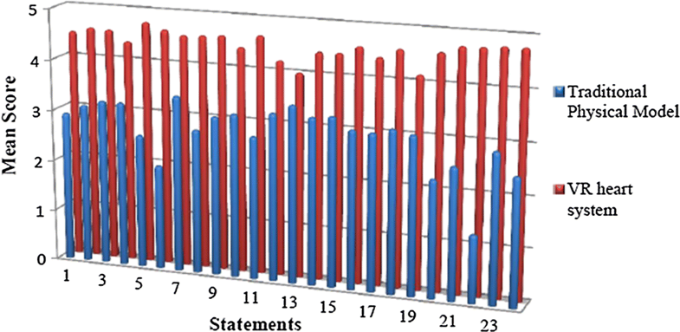](https://media.springernature.com/original/springer-static/image/art%3A10.1007%2Fs10055-018-0359-y/MediaObjects/10055_2018_359_Fig3_HTML.png)](https://media.springernature.com/original/springer-static/image/art%3A10.1007%2Fs10055-018-0359-y/MediaObjects/10055_2018_359_Fig3_HTML.png)

**Fig. 3**

Questionnaire results comparing each statement mean values for traditional physical model with the VR Anatomy System. The VR Anatomy System had higher mean scores than the traditional physical model for all the questionnaire statements

[Open image in new window[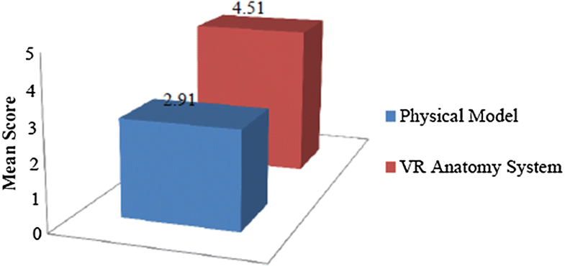](https://media.springernature.com/original/springer-static/image/art%3A10.1007%2Fs10055-018-0359-y/MediaObjects/10055_2018_359_Fig4_HTML.png)](https://media.springernature.com/original/springer-static/image/art%3A10.1007%2Fs10055-018-0359-y/MediaObjects/10055_2018_359_Fig4_HTML.png)

**Fig. 4**

Questionnaire results comparing overall mean values for traditional physical model with VR Anatomy System

4 Conclusions and future work

This paper presented the comparative testing conducted for system evaluation. This entailed comparing the efficiency of the interactive VR heart anatomy system with the traditional modalities of learning anatomy. The evaluation was based on students’ trials by navigating through the system with the provided tools and functionalities. The results demonstrated the usefulness of the provided system by showing a higher satisfaction rate for the provided tools regarding structure and visualisation. The quantitative and qualitative analysed data demonstrated the effectiveness of the provided system by showing a higher satisfaction rate for the provided tools regarding structure and visualisation.

The outcome of this paper demonstrates the huge potential of using novel technology in medical education. Virtual reality technology facilitates the delivery of information in a user-friendly environment, improving understanding and visualisation of the complex anatomical structures and interrelations, thereby transforming the educational process into a more efficient and dynamic one.

References

1. Alfalah SF, Harrison DK, Charissis V, Evans D (2013a) An investigation of a healthcare management system with the use of multimodal interaction and 3D simulation: a technical note. J Enterp Inf Manag 26:183–197. ISSN: 1741-0398.  <https://doi-org.erl.lib.byu.edu/10.1007/978-3-642-39420-1_1>
2. Alfalah SF, Harrison DK, Charissis V (2013b) Gait analysis management and diagnosis in a prototype virtual reality environment. In: Virtual, augmented and mixed reality. Systems and applications, Springer, Berlin, pp 3–11. ISSN: 0302-9743.  <https://doi-org.erl.lib.byu.edu/10.1007/978-3-642-39420-1_1>
3. Charissis V, Papanastasiou S (2010) Human–machine collaboration through vehicle head up display interface. Cognit Technol Work 12(1):41–50[CrossRef](https://doi-org.erl.lib.byu.edu/10.1007/s10111-008-0117-0)[Google Scholar](http://scholar.google.com.erl.lib.byu.edu/scholar_lookup?title=Human%E2%80%93machine%20collaboration%20through%20vehicle%20head%20up%20display%20interface&author=V.%20Charissis&author=S.%20Papanastasiou&journal=Cognit%20Technol%20Work&volume=12&issue=1&pages=41-50&publication_year=2010)
4. Cronbach LJ (1951) Coefficient alpha and the internal structure of tests. Psychometrika 16(3):297–334[CrossRef](https://doi-org.erl.lib.byu.edu/10.1007/BF02310555)[zbMATH](http://www.emis.de.erl.lib.byu.edu/MATH-item?1367.62314)[Google Scholar](http://scholar.google.com.erl.lib.byu.edu/scholar_lookup?title=Coefficient%20alpha%20and%20the%20internal%20structure%20of%20tests&author=LJ.%20Cronbach&journal=Psychometrika&volume=16&issue=3&pages=297-334&publication_year=1951)
5. Cronbach LJ, Furby L (1970) How should we measure “change”- or should we? Psychol Bull 74:68–80[CrossRef](https://doi-org.erl.lib.byu.edu/10.1037/h0029382)[Google Scholar](http://scholar.google.com.erl.lib.byu.edu/scholar_lookup?title=How%20should%20we%20measure%20%E2%80%9Cchange%E2%80%9D-%20or%20should%20we%3F&author=LJ.%20Cronbach&author=L.%20Furby&journal=Psychol%20Bull&volume=74&pages=68-80&publication_year=1970)
6. Engum SA, Jeffries P, Fisher L (2003) Intravenous catheter training system: computer-based education versus traditional learning methods. Am J Surg 186(1):67–74[CrossRef](https://doi-org.erl.lib.byu.edu/10.1016/S0002-9610(03)00109-0)[Google Scholar](http://scholar.google.com.erl.lib.byu.edu/scholar_lookup?title=Intravenous%20catheter%20training%20system%3A%20computer-based%20education%20versus%20traditional%20learning%20methods&author=SA.%20Engum&author=P.%20Jeffries&author=L.%20Fisher&journal=Am%20J%20Surg&volume=186&issue=1&pages=67-74&publication_year=2003)
7. Falah J, Harrison DK, Wood B, Evans D (2012) The characterisation of an IT system to reduce the gap between information technology and medical education. In: International conference on manufacturing research (ICMR). vol. 2, pp 360–365. ISBN: 9781905866601[Google Scholar](https://scholar-google-com.erl.lib.byu.edu/scholar?q=Falah%20J%2C%20Harrison%20DK%2C%20Wood%20B%2C%20Evans%20D%20%282012%29%20The%20characterisation%20of%20an%20IT%20system%20to%20reduce%20the%20gap%20between%20information%20technology%20and%20medical%20education.%20In%3A%20International%20conference%20on%20manufacturing%20research%20%28ICMR%29.%20vol.%202%2C%20pp%20360%E2%80%93365.%20ISBN%3A%209781905866601)
8. Falah J, Harrison DK, Charissis V, Wood BM (2013) The characterisation of a virtual reality system to improve the quality and to reduce the gap between information technology and medical education. In: Virtual, augmented and mixed reality. systems and applications, vol 2. Springer, Berlin. pp 122–131.  <https://doi-org.erl.lib.byu.edu/10.1007/978-3-642-39420-1_14>
9. Falah J, Khan S, Alfalah T, Alfalah SFM, Chan W, Harrison DK, Charissis V (2014) Virtual reality medical training system for anatomy education. In: Science and information conference (SAI). IEEE. pp 752–758.  <https://doi-org.erl.lib.byu.edu/10.1109/sai.2014.6918271>
10. Falah J, Charissis V, Khan S, Chan W, Alfalah SF, Harrison DK (2015) Development and evaluation of virtual reality medical training system for anatomy education. In: Chen L, Kapoor S, Bhatia R (eds) Intelligent systems in science and information. Springer, Berlin, pp 369–383.  <https://doi-org.erl.lib.byu.edu/10.1007/978-3-319-14654-6_23>[Google Scholar](http://scholar.google.com.erl.lib.byu.edu/scholar_lookup?title=Development%20and%20evaluation%20of%20virtual%20reality%20medical%20training%20system%20for%20anatomy%20education&author=J.%20Falah&author=V.%20Charissis&author=S.%20Khan&author=W.%20Chan&author=SF.%20Alfalah&author=DK.%20Harrison&pages=369-383&publication_year=2015)
11. Gallo L, Minutolo A, De Pietro G (2010) A user interface for VR-ready 3D medical imaging by off-the-shelf input devices. Comput Biol Med 40(3):350–358[CrossRef](https://doi-org.erl.lib.byu.edu/10.1016/j.compbiomed.2010.01.006)[Google Scholar](http://scholar.google.com.erl.lib.byu.edu/scholar_lookup?title=A%20user%20interface%20for%20VR-ready%203D%20medical%20imaging%20by%20off-the-shelf%20input%20devices&author=L.%20Gallo&author=A.%20Minutolo&author=G.%20Pietro&journal=Comput%20Biol%20Med&volume=40&issue=3&pages=350-358&publication_year=2010)
12. Onyesolu M (2009) Virtual reality laboratories: an ideal solution to the problems facing laboratory setup and management. In: Proceedings of the world congress on engineering and computer science, San Francisco, USA. 1. ISBN: 978-988-17012-6-8[Google Scholar](https://scholar-google-com.erl.lib.byu.edu/scholar?q=Onyesolu%20M%20%282009%29%20Virtual%20reality%20laboratories%3A%20an%20ideal%20solution%20to%20the%20problems%20facing%20laboratory%20setup%20and%20management.%20In%3A%20Proceedings%20of%20the%20world%20congress%20on%20engineering%20and%20computer%20science%2C%20San%20Francisco%2C%20USA.%201.%20ISBN%3A%20978-988-17012-6-8)
13. Peterson D, Robertson C (2013) Utilizing virtual reality in teaching and training: progress toward virtual surgical simulations. In: INTED2013 proceedings. pp 3285–3291[Google Scholar](https://scholar-google-com.erl.lib.byu.edu/scholar?q=Peterson%20D%2C%20Robertson%20C%20%282013%29%20Utilizing%20virtual%20reality%20in%20teaching%20and%20training%3A%20progress%20toward%20virtual%20surgical%20simulations.%20In%3A%20INTED2013%20proceedings.%20pp%203285%E2%80%933291)
14. Sakellariou S, Ward BM, Charissis V, Chanock D, Anderson P (2009) Design and implementation of augmented reality environment for complex anatomy training: inguinal canal case study. In: Virtual and mixed reality, Springer, Berlin, pp 605–614, 0302–9743.  <https://doi-org.erl.lib.byu.edu/10.1007/978-3-642-02771-0_67>
15. Sakellariou S, Charissis V, Grant S, Turner J, Kelly D, Christomanos C (2011) Virtual reality as knowledge enhancement tool for musculoskeletal pathology. In: Virtual and mixed reality-systems and applications, Springer, Berlin, pp 54–63. ISSN: 0302-9743.  <https://doi-org.erl.lib.byu.edu/10.1007/978-3-642-22024-1_7>
16. Saunders M, Lewis P, Thornhill A (2012) Research methods for business student, Pearson Education Limited, Edinburgh Gate Harlow, England, pp 430–436. ISBN: 9780273750758[Google Scholar](https://scholar-google-com.erl.lib.byu.edu/scholar?q=Saunders%20M%2C%20Lewis%20P%2C%20Thornhill%20A%20%282012%29%20Research%20methods%20for%20business%20student%2C%20Pearson%20Education%20Limited%2C%20Edinburgh%20Gate%20Harlow%2C%20England%2C%20pp%20430%E2%80%93436.%20ISBN%3A%209780273750758)
17. Vozenilek J, Huff JS, Reznek M, Gordon JA (2004) See one, do one, teach one: advanced technology in medical education. Acad Emerg Med 11(11):1149–1154.  [https://doi-org.erl.lib.byu.edu/10.1197/j.aem.2004.08.003CrossRef](https://doi-org.erl.lib.byu.edu/10.1197/j.aem.2004.08.003)[Google Scholar](http://scholar.google.com.erl.lib.byu.edu/scholar_lookup?title=See%20one%2C%20do%20one%2C%20teach%20one%3A%20advanced%20technology%20in%20medical%20education&author=J.%20Vozenilek&author=JS.%20Huff&author=M.%20Reznek&author=JA.%20Gordon&journal=Acad%20Emerg%20Med&volume=11&issue=11&pages=1149-1154&publication_year=2004&doi=10.1197%2Fj.aem.2004.08.003)

Copyright information

© Springer-Verlag London Ltd., part of Springer Nature 2018

About this article

[CrossMark](https://crossmark.crossref.org/dialog/?doi=10.1007%2Fs10055-018-0359-y)

**Cite this article as:**

Alfalah, S.F.M., Falah, J.F.M., Alfalah, T. et al. Virtual Reality (2018). https://doi-org.erl.lib.byu.edu/10.1007/s10055-018-0359-y

* **Received**22 February 2017

* **Accepted**16 July 2018

* **First Online**27 July 2018
* **DOI**https://doi-org.erl.lib.byu.edu/10.1007/s10055-018-0359-y

* **Publisher Name**Springer London

* **Print ISSN**1359-4338
* **Online ISSN**1434-9957
* [About this journal](https://www-springer-com.erl.lib.byu.edu/journal/10055/about)
* [Reprints and Permissions](https://s100.copyright.com/AppDispatchServlet?publisherName=SpringerNature&orderBeanReset=true&orderSource=SpringerLink&copyright=Springer-Verlag+London+Ltd.%2C+part+of+Springer+Nature&author=Salsabeel+F.+M.+Alfalah%2C+Jannat+F.+M.+Falah%2C+Tasneem+Alfalah+et+al&contentID=10.1007%2Fs10055-018-0359-y&endPage=6&publicationDate=2018&startPage=1&title=A+comparative+study+between+a+virtual+reality+heart+anatomy+system+and+traditional+medical+teaching+modalities&imprint=Springer-Verlag+London+Ltd.%2C+part+of+Springer+Nature&publication=1359-4338)

Actions

[Download PDF](https://link-springer-com.erl.lib.byu.edu/content/pdf/10.1007%2Fs10055-018-0359-y.pdf)

Cite article

* [How to cite?](https://link-springer-com.erl.lib.byu.edu/article/10.1007/s10055-018-0359-y#citeas)
* [.RISPapersReference ManagerRefWorksZotero](https://citation-needed-springer-com.erl.lib.byu.edu/v2/references/10.1007/s10055-018-0359-y?format=refman&flavour=citation)
* [.ENWEndNote](https://citation-needed-springer-com.erl.lib.byu.edu/v2/references/10.1007/s10055-018-0359-y?format=endnote&flavour=citation)
* [.BIBBibTeXJabRefMendeley](https://citation-needed-springer-com.erl.lib.byu.edu/v2/references/10.1007/s10055-018-0359-y?format=bibtex&flavour=citation)

[Share article](https://link-springer-com.erl.lib.byu.edu/sharelink/10.1007/s10055-018-0359-y)

Table of contents

* [Article](https://link-springer-com.erl.lib.byu.edu/article/10.1007/s10055-018-0359-y#enumeration)
* [Abstract](https://link-springer-com.erl.lib.byu.edu/article/10.1007/s10055-018-0359-y#Abs1)
* [1 Introduction](https://link-springer-com.erl.lib.byu.edu/article/10.1007/s10055-018-0359-y#Sec1)
* [2 Experiment rationale](https://link-springer-com.erl.lib.byu.edu/article/10.1007/s10055-018-0359-y#Sec2)
* [3 Results and analysis](https://link-springer-com.erl.lib.byu.edu/article/10.1007/s10055-018-0359-y#Sec6)
* [4 Conclusions and future work](https://link-springer-com.erl.lib.byu.edu/article/10.1007/s10055-018-0359-y#Sec7)
* [References](https://link-springer-com.erl.lib.byu.edu/article/10.1007/s10055-018-0359-y#Bib1)
* [Copyright information](https://link-springer-com.erl.lib.byu.edu/article/10.1007/s10055-018-0359-y#copyrightInformation)
* [About this article](https://link-springer-com.erl.lib.byu.edu/article/10.1007/s10055-018-0359-y#aboutcontent)

Over 10 million scientific documents at your fingertips

Academic Edition

* [Corporate Edition](https://link-springer-com.erl.lib.byu.edu/siteEdition/rd?previousUrl=/article/10.1007/s10055-018-0359-y&id=siteedition-corporate-link)
* [Home](https://link-springer-com.erl.lib.byu.edu/)
* [Impressum](https://link-springer-com.erl.lib.byu.edu/impressum)
* [Legal information](https://link-springer-com.erl.lib.byu.edu/termsandconditions)
* [Privacy statement](https://link-springer-com.erl.lib.byu.edu/privacystatement)
* [How we use cookies](https://link-springer-com.erl.lib.byu.edu/cookiepolicy)
* [Accessibility](https://link-springer-com.erl.lib.byu.edu/accessibility)
* [Contact us](https://link-springer-com.erl.lib.byu.edu/contactus)

[Springer Nature](https://www.springernature.com/)

© 2018 Springer Nature Switzerland AG. Part of [Springer Nature](https://www.springernature.com/).

Not logged in Brigham Young Univ, 260 JRCB 2217 Harold B. Lee Library, Room 3830 (3000058001) - GWLA (3000123364) 128.187.103.98